**ACTIVITY 1**

**Individual work !**

1. Draw the DOM tree for the HTML code below :

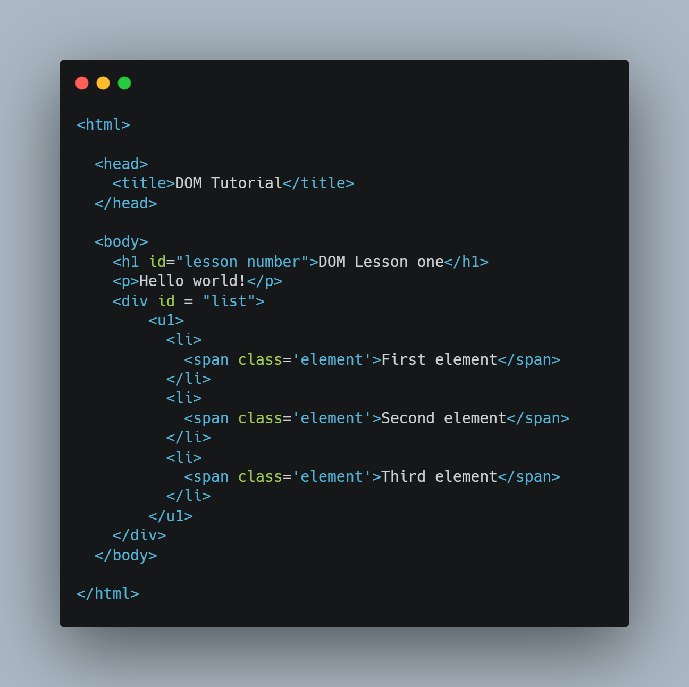

Li

text

Ul

div

text

text

P

H1

Head

HTML

Title

Body

1. **Answer the questions :**

|  |  |
| --- | --- |
| How many **children** does the <h1> node have | DOM |
| How many **children** does the <head> node have | 1 = title |
| How many **siblings** does the first <li> node have | 2 = second and third |
| Who is the **parent** of the second <span> node | Second il |
| Who is the **parent** of the <ul> node | div |
| Who is the **first child** of the <body> node | H1 |
| How many **children** does the <body> node have | 3 = h1, P, div |
| How many **siblings** does the <ul> sibling have | No |
| What is the **root** **node**, does it have parents | Root node is the Html.No |